# The Question

This is going to take some explanation before I can get to the question. The requirement for this task is:

"We should plot the "Probable Bearing Error" as +/- two degrees to define the shaded area, with dashed lines at +/- four degrees (95% POC) to be consistent with other displays."

So the display should be something like this:

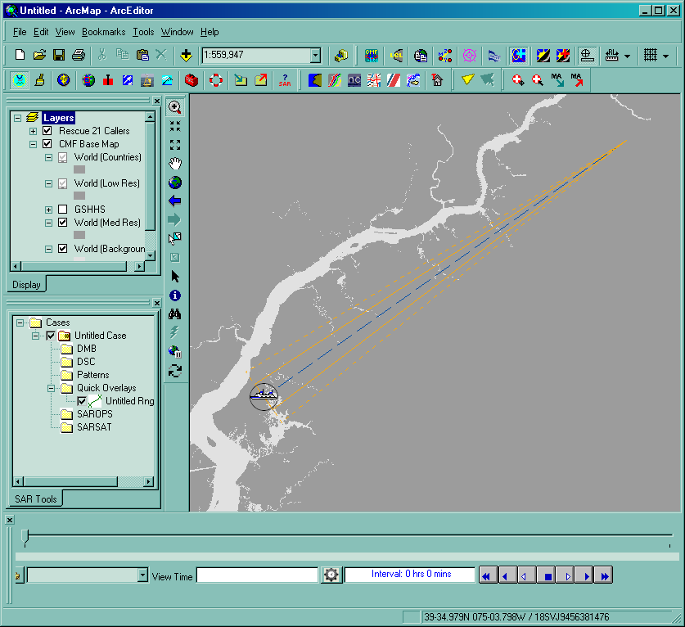

The problem is that the calculations are not obvious given the inputs. Look at the following diagram:



What we are given in the R21 message is the latitude/longitude of both the O (origin) and C (center) points, the distance in nautical miles from A to B (i.e the "base" of the triangle), the great circle bearing from O to C, and the GC distance from O to C.

**Question #1: How should A and B be calculated in a geodetically correct manner?**

**Question #2: If the A’-O-C angle is twice the A-O-C angle, how should A’ and B’ be calculated in a geodetically correct manner?**

# Current Practice

Currently, SARTools is calculating A and B as follows:

* bearingCA = bearingOC – 90 degs
* halfBase = base/2
* A = geodesic_coordinate(C, bearingCA, halfBase)
* bearingCB = bearingOC + 90 degs
* B = geodesic_coordinate(C, bearingCB, halfBase)

(Where geodesic_coordinate() is a standard geodetic function that computes the great circle lat/lng endpoint given a starting point, bearing, and distance.)

Then bearing error is calculated as follows:

* bearingOA = geodesic_distance(O, A)
* bearingError = bearingOA - bearingOC

(Where geodesic_distance() is a standard geodetic function that computes the great circle distance between two given points)

**Question #3: Are these calculations even correct?**

# Mapping from R21 XML

Just for documentation purposes, here is the XML message that generated the section 1 figure, annotated with source of above values:

<USCGDocument xmlns:xsd="http://www.w3.org/2001/XMLSchema"   
 xmlns:xsi="http://www.w3.org/2001/XMLSchema-instance">

<Header>

<type>publication://uscg.mda.sar/call/DelawareBay</type>

<status>publication</status>

<modified>2011-04-13T02:13:33.729Z</modified>

<auditTrail>

<entry>

<router>32046@osc-esb-ps002.osc.uscg.mil</router>

<configId>197af3f5</configId>

<domain>AESIR_Business_Prod_04122011</domain>

<status>PUBLICATION</status>

<created>2011-04-13T02:13:33.729Z</created>

</entry>

</auditTrail>

<created>2011-04-13T02:13:30Z</created>

</Header>

distanceOC

<Publication>

<Caller>

base

<SemiMajorAxis>33.386817932128906</SemiMajorAxis>

<SemiMinorAxis>2.3317866325378418</SemiMinorAxis>

<RotationAngle>234.7239990234375</RotationAngle>

C

bearingOC

<Lat>39.648083</Lat>

<Lon>-75.4877</Lon>

<IsDeleted>false</IsDeleted>

<PositionTimeStamp>2011-04-13T02:11:07Z</PositionTimeStamp>

<CallID>9867e83e-99f5-482b-a305-db598bc02661</CallID>

<Description>Hello World from Landdon Doan</Description>

<VesselInformation>FAT SAROPS Test Caller</VesselInformation>

<NumberOfPeople>-1</NumberOfPeople>

<CategoryType>15</CategoryType>

<PositionValidEnum>2</PositionValidEnum>

<Fix>

<SemiMajorAxis>33.386817932128906</SemiMajorAxis>

<SemiMinorAxis>2.3317866325378418</SemiMinorAxis>

<RotationAngle>234.7239990234375</RotationAngle>

<Lat>39.648086</Lat>

<Lon>-75.487701</Lon>

<IsDeleted>false</IsDeleted>

<PositionTimeStamp>2011-04-13T02:11:07Z</PositionTimeStamp>

<FixID>8279cd8f-47c2-42b2-b068-0385fdd4f847</FixID>

<Type>9</Type>

<Elob>

<ElobID>257255f2-60fa-4288-ae94-40f69c0a44c2</ElobID>

<Name>Burlington</Name>

<HasAudio>true</HasAudio>

<Channel>83</Channel>

<Bearing>234.724</Bearing>

<Length>33.386817932128906</Length>

<AudioFile>http://1.2.3.4/fake/to/foo.wav</AudioFile>

<IsOth>true</IsOth>

<TowerHeight>470</TowerHeight>

O

<Lat>39.970361</Lat>

<Lon>-74.898777</Lon>

<IsDeleted>false</IsDeleted>

<PositionTimeStamp>2011-04-13T02:11:07Z</PositionTimeStamp>

</Elob>

<PositionValidEnum>2</PositionValidEnum>

</Fix>

</Caller>

</Publication>

</USCGDocument>